Board of Trustees Member
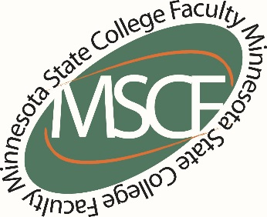
Minnesota State Colleges and Universities
30 7th Street East, Suite 350
St. Paul, MN 55101-7804
August 16, 2016
Dear Board of Trustees Member:
I am a faculty member at Anoka Ramsey Community College and am writing regarding the recommendations brought forward by the Task Force on Long Term Financial Sustainability. The proposed recommendations shift the focus from our students receiving an extraordinary education to promoting a business-like model that puts financial efficiencies first. Such an approach would truly create a crisis in our ability to carry out our mission of providing an extraordinary education that is accessible and affordable for all Minnesotans.

A commitment to an extraordinary education recognizes and respects the uniqueness and autonomy of our campuses and the economic and cultural vitality they contribute to the communities they serve. Streamlined curriculum and centralized services may be simpler, but their cost, in terms of lost opportunity and access, is incalculable.

A commitment to an extraordinary education recognizes how integral all faculty are to students’ ability to succeed. If we truly care about closing the achievement gap we must invest in diverse, committed, full time faculty members who are able to build relationships with their students and the community. Efforts to divide and devalue our faculty destabilize our classrooms and colleges, and disrupt student learning. Our state’s commitment to a largely full time stable faculty who are best able to meet the needs of students, students who continue to come to our classrooms with an increasingly wide variety of needs and challenges, is and should remain a point of pride. This is not at all reflected in the executive summary written by the workgroup appointed by Chancellor Rosenstone. In fact the opposite appears true. The recommendations in the Report on Long Term Sustainability put forward by the Chancellor’s office suggests that a less stable faculty (an increase in adjunct over full-time faculty that may lack connection to our individual institutions including but not limited to a decrease in the ability of students to interact with said faculty) with less control over the tools used to educate would be more successful. We categorically reject this idea as scientifically and statistically flawed, with no serious research to support his assumptions.

All of the recommendations in this report are built upon the conclusion that the current financial model is unsustainable. The financial forecast underlying that conclusion is questionable as it assumes that state funding will continue to decrease at a consistent rate until it reaches zero while maintaining the current tuition freeze, operating at 2016 tuition levels into 2026. These conditions are unlikely to occur and represent the worst case scenario. Even a small change to these underlying assumptions, over a 10 year period, will substantially change the financial picture. This report on long term financial sustainability represents a manufactured crisis that, while possible, is extremely unlikely. It is simply an excuse to implement an agenda not directly related to financial sustainability.

We have experienced challenges in the past, and, as individual colleges and a system, have emerged from those challenges by engaging in inclusive, respectful, fully transparent discussions that put students and our responsibility to provide an accessible, affordable extraordinary education at the center of any proposed solutions. We are always ready to engage in efforts to expand and improve access to the education and opportunities our students receive in our classrooms and throughout our campuses; however, these recommendations threaten to do just the opposite. The “education as a business” model that these recommendations reflect, by equating simplicity with efficiency, bigger with better, and sacrificing student needs for bottom line thinking, have proven to be fundamental failures and must be rejected. Therefore, I ask that you reject the proposed recommendations and commit to an inclusive, transparent process that puts students first.

Sincerely,

Anoka Ramsey Community College

